***DATA ANALYSIS USING POWER BI***

1. **Sales performance report:**

Create a table and add sales person in the value field. Create a new measure TotalAmount=sum (sales [TotalAmount]). Add the measure TotalAmount in the table field.

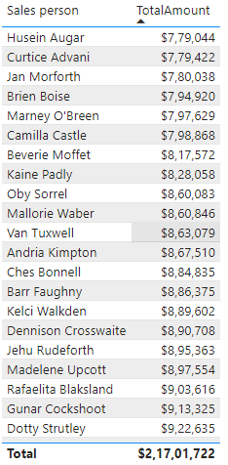

1. **Team wise performance report:**

Create a slicer. Add the “teams” field to the value

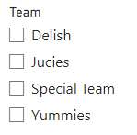

1. **Sales person-Total quantity report:**

Create a new measure “Total quantity”. “Total quantity=sum (sales [Product])”. Add it to the table.

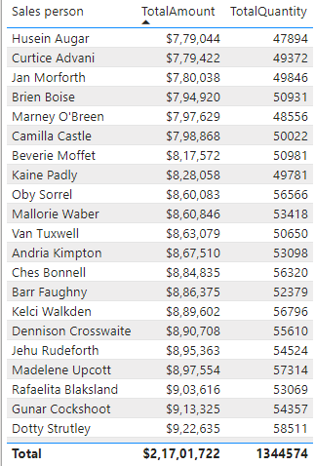

1. **Amount per box:**

Add a new measure amount per box. “Amount per box=[TotalAmount]/[TotalQuantity]”



Add the new measure to the table field.

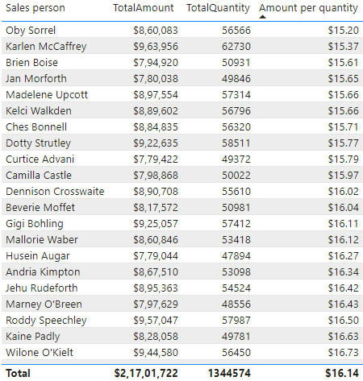

1. **Add pictures of the corresponding salesperson to the table:**

Change the value of Picture in persons table in data category of column tools to “Image URL”. Add the picture value to the table.

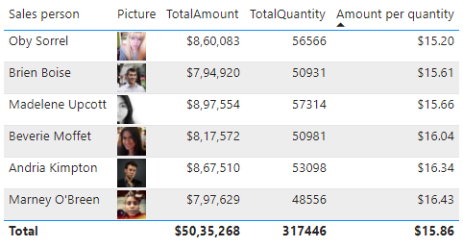

1. **Total Amount by Category:**

Add a stacked column chart with category in the axis and total amount in the values field.

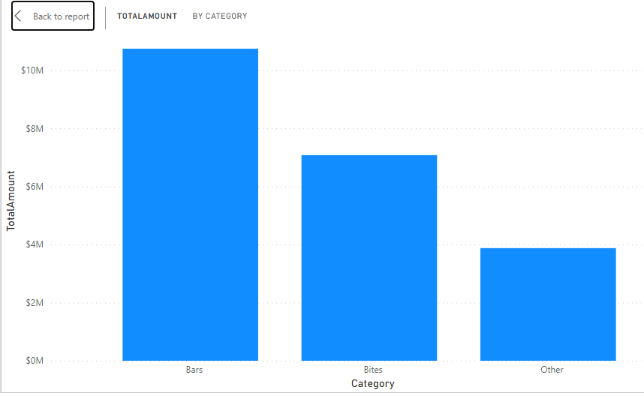

1. **Total amount by geography:**

Add a staked bar chart with “Geography” in the X-axis and “TotalAmount” in the Y-axis

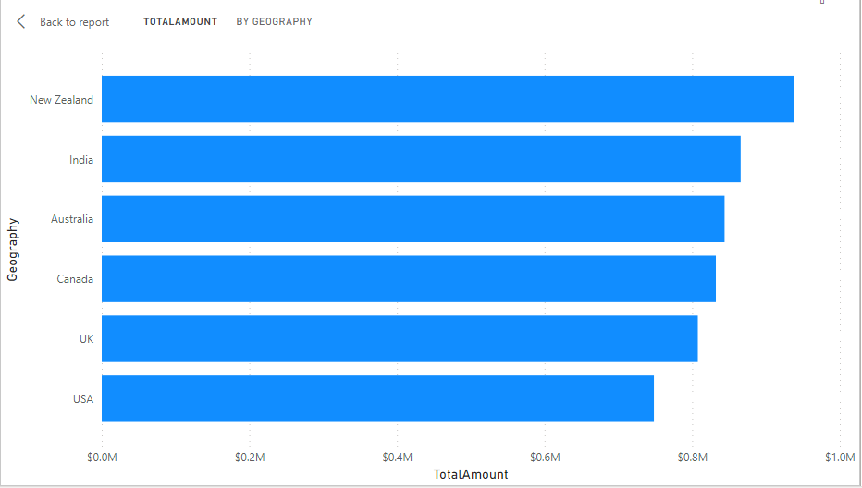

1. **Add a title:**

Add a text box with “SALES PERFORMANCE REPORT” and format it.

